# CS 255 System Design Document Template

This template lays out all the different sections that you need to complete for Project Two. Each section has guidance to prompt your thinking. You will need to continually reference the interview transcript as you work to make sure that you are addressing your client’s needs. There is no required length for the final document. Instead the goal is to complete each section based on what your client’s needs are. Remove this note when you are finished, and replace all bracketed text with the relevant information.

## UML Diagrams

### UML Use Case Diagram

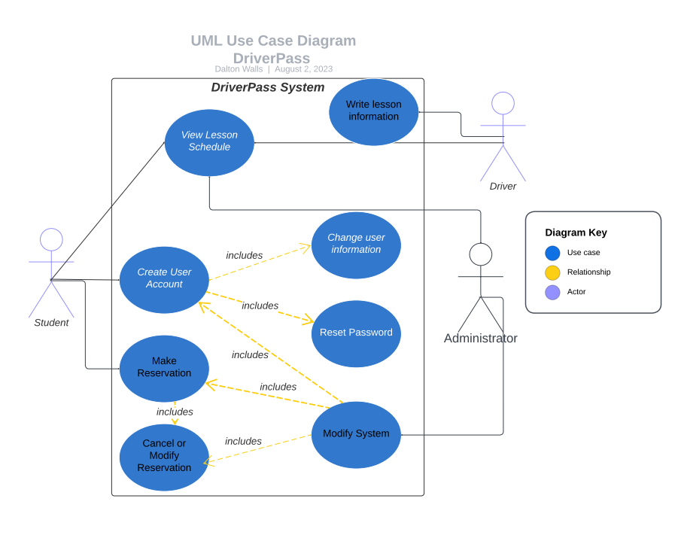

### UML Activity Diagrams

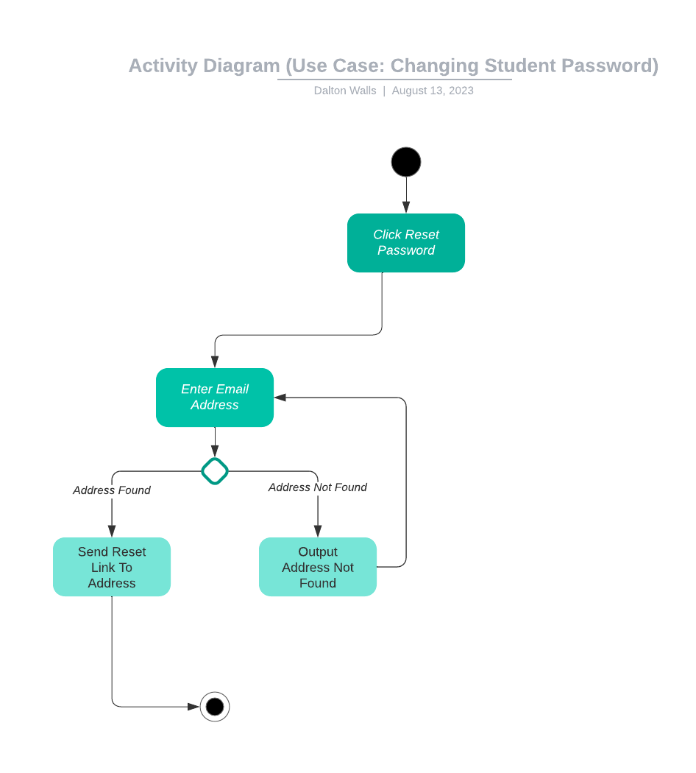

### UML Class Diagram

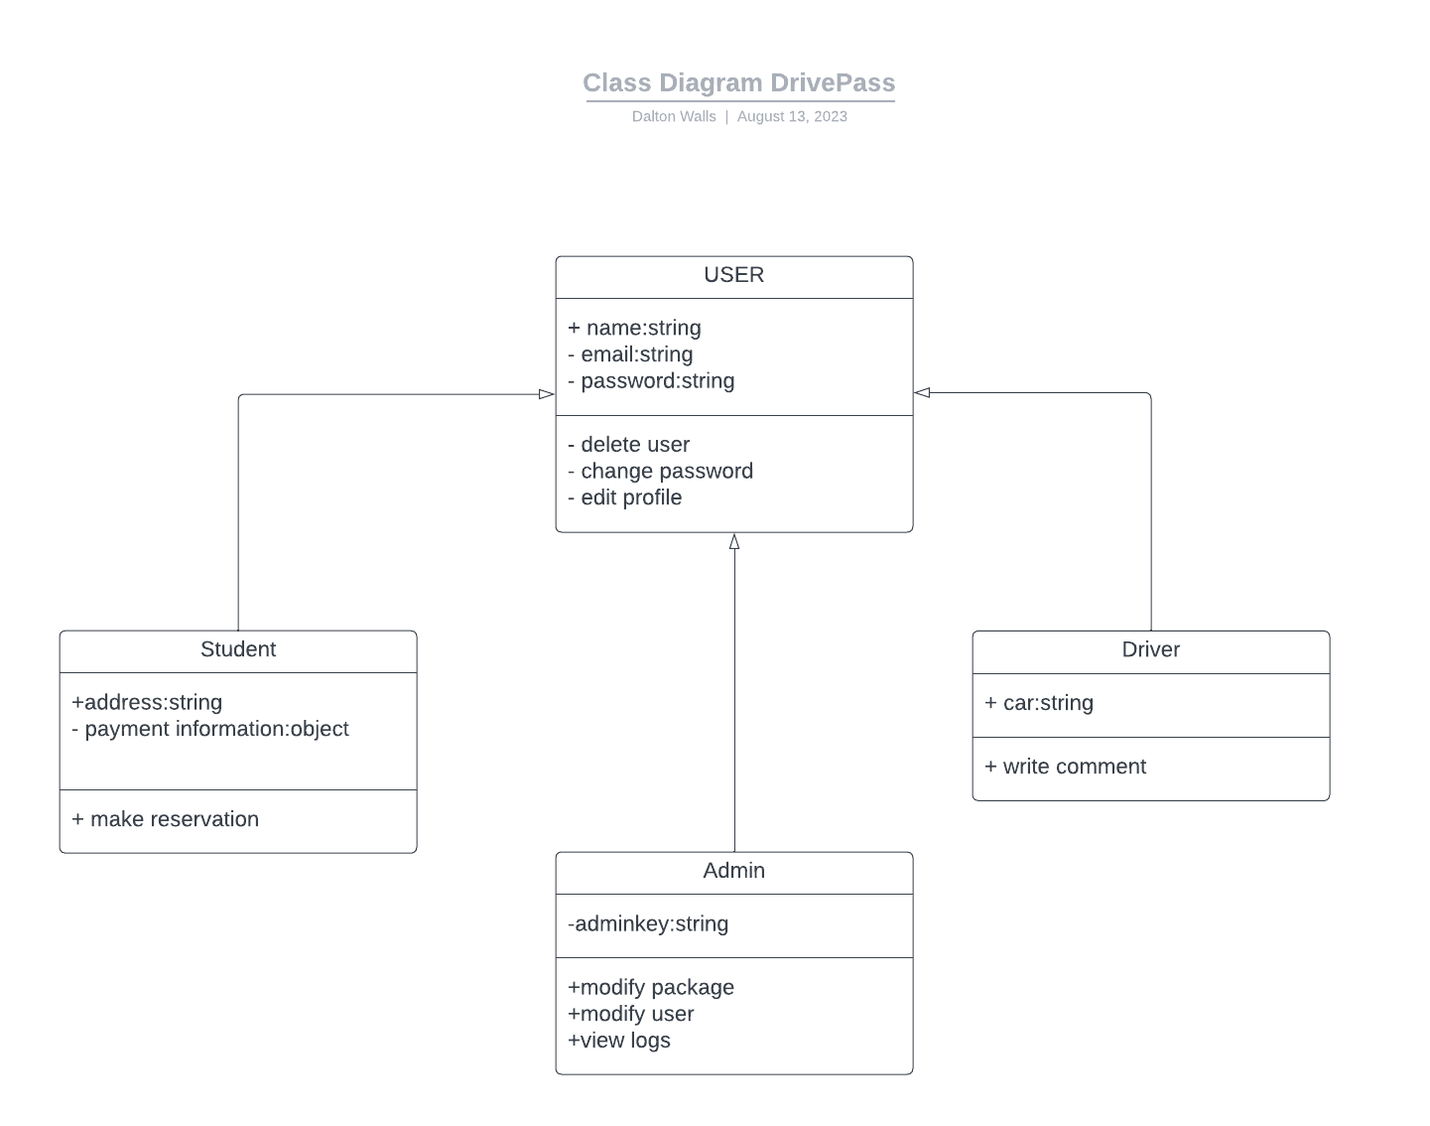

## Technical Requirements

*+ phone system for receptionist*

*+ pc with access to database for appointments*

*+ cloud based service with server and database*

*+ website fully compatible with different OS and browsers*

*+ website accessible from any device*

*+ quick speed*